DPR APPRAISAL AUTOMATION SYSTEM
Technical Design Document

Executive Summary 3
1. Introduction and Context 4
1.1 Current Appraisal Process 4
1.2 Challenges in Current Process 4
2. Solution 1: POC - Intelligent Query Assistant 5
2.1 Overview 5
2.2 Technical Architecture 5
2.3 Query Processing Workflow (indicative) 6
2.4 Technical Components (Indicative) 6
3. Solution 2: Full Production System - Automated DPR Appraisal Platform 7
3.1 Overview 7
3.2 System Architecture 7
3.3 Multi-Agent Processing Workflow 8
3.4 Agent Specializations (Indicative) 8
3.5 Infrastructure Requirements (Indicative) 9
Hardware Specifications (Indicative) 9
Software Stack (Indicative) 9
4. Conclusion 9
4.1 Key Benefits 9

Executive Summary
The Department of Expenditure (DoE) currently processes project appraisals through a multi-stage manual review process, involving assessment of project proposals against established guidelines, fiscal norms, and inter-ministerial consultations. This process, while thorough, is time-intensive and requires Subject Officers (SOs) to navigate extensive documentation including General Financial Rules (GFR), Detailed Financial Procedures and Rules (DFPR), Office Memorandums (OMs), and historical appraisal records.
To enhance efficiency and decision-making capability, this document presents a phased automation approach:
Phase 1: Proof of Concept (POC) - Intelligent Query Assistant
The initial phase focuses on creating an AI-powered query assistant with publicly available appraisal guidelines and policy documents. This POC system will enable SOs to obtain instant clarifications on appraisal procedures, financial norms, and policy interpretations without processing any confidential project documents. The system utilizes a curated knowledge repository of public documents, including GFR, DFPR, standard templates, and published OMs and Appraisal and approval Guidelines to provide contextual responses to officer queries.
Phase 2: Full Production System - Automated DPR Appraisal Platform
The production system will implement complete on-premise inferencing infrastructure to process confidential DPR documents. This multi-agent architecture will automate assessment across all appraisal dimensions—need analysis, cost scrutiny, implementation feasibility, and inter-ministerial coordination—while maintaining data security through dedicated inference servers deployed within DoE's secure environment.
Both phases leverage a structured knowledge repository architecture that organizes reference materials into specialized vaults, enabling precise retrieval and context-aware responses. This document provides detailed technical specifications, architecture diagrams, implementation workflows, and deployment considerations for both solutions.

1. Introduction and Context

1.1 Current Appraisal Process
The Department of Expenditure follows a structured appraisal workflow for project proposals:
Figure 1: Current DPR Appraisal Workflow
Ministry prepares Concept Note / DPR
↓
Submission to Department of Expenditure
↓
Preliminary Check by DoE
(Completeness, Format, In-principle Approval)
↓
Multi-Dimensional Appraisal
Need &  Relevance | Outcome &  Performance | Cost & Fiscal  Scrutiny | Implementation  & Risk | Inter-Ministerial  Consultation

1.2 Challenges in Current Process
Challenge | Impact
Information Retrieval | Subject Officers must manually search through extensive documentation (GFR, DFPR, OMs) to locate relevant guidelines
Processing Time | Multi-dimensional assessment across five parameters requires significant time per proposal
Consistency | Varying interpretation of guidelines across different appraisals and officers
Knowledge Management | Historical appraisal decisions and institutional knowledge not systematically captured or accessible

2. Solution 1: POC - Intelligent Query Assistant

2.1 Overview
The Proof of Concept implements an AI-powered query assistant system that enables Subject Officers to obtain instant, contextual responses to appraisal-related queries. The system operates exclusively on publicly available guidelines and policy documents, leveraging managed AI infrastructure.
Characteristic | Details
Scope | Public documents only (GFR, DFPR, published OMs, standard templates)
Use Case | Query resolution on appraisal procedures, financial norms, policy interpretation
Timeline (tentative) | 4-6 weeks for initial deployment

2.2 Technical Architecture
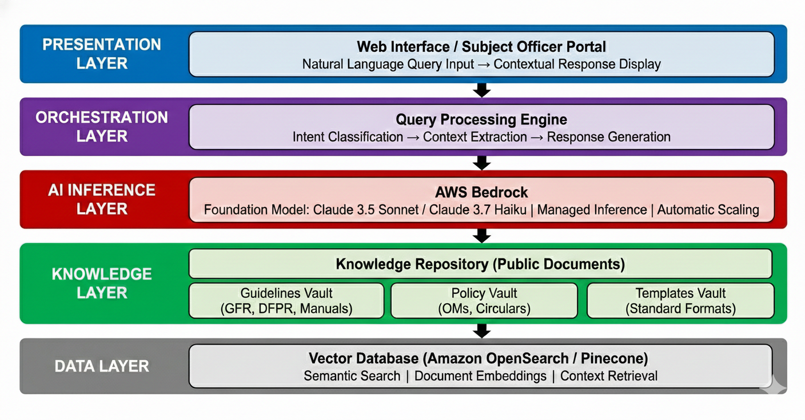
Figure 2: POC System Architecture

2.3 Query Processing Workflow (indicative)

Figure 3: Query Processing Flow
Step 1: Query Input
Subject Officer submits natural language query
Example: "What is the 5.5x rule for cost norms?"
↓
Step 2: Query Understanding
Intent classification → Extract key entities → Generate embedding vector
↓
Step 3: Context Retrieval
Semantic search in vector DB → Retrieve top-K relevant document chunks
↓
Step 4: Response Generation
AWS Bedrock (Claude) generates contextual response with source citations
↓
Step 5: Response Delivery
Formatted answer with references → Display to Subject Officer

2.4 Technical Components (Indicative)
Component | Specification
Foundation Model | Claude 3.5 Sonnet (comprehensive responses) or Claude 3.7 Haiku (quick queries) via AWS Bedrock
Embedding Model | Amazon Titan Embeddings V2 (512-1024 dimensions for semantic search)
Vector Store | Amazon OpenSearch Service with k-NN plugin or Pinecone (managed vector DB)
Orchestration | AWS Lambda (serverless functions) + API Gateway for request routing
Frontend | React.js web application hosted on AWS Amplify or S3+CloudFront
Document Storage | Amazon S3 (public documents repository with versioning)

3. Solution 2: Full Production System - Automated DPR Appraisal Platform

3.1 Overview
The production system represents a comprehensive multi-agent architecture designed to automate the complete DPR appraisal workflow. This system processes confidential project documents through specialized AI agents, each responsible for specific assessment dimensions, while maintaining strict data security through dedicated on-premise inferencing infrastructure.
Characteristic | Details
Scope | Full DPR processing including confidential project documents and sensitive financial data
Infrastructure | On-premise GPU servers with local model inferencing - NO cloud-based AI services
Security Model | Complete data residency within DoE infrastructure, air-gapped processing for sensitive documents
Processing Mode | Multi-agent orchestration with specialized assessment agents for each appraisal dimension

3.2 System Architecture

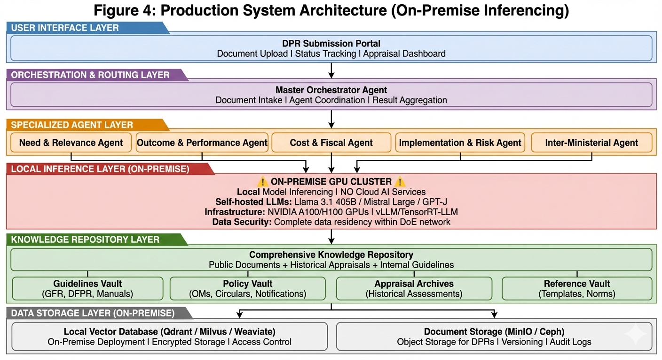

3.3 Multi-Agent Processing Workflow

Figure 5: DPR Processing Workflow with Specialized Agents
Phase 1: Document Ingestion
DPR uploaded → Document parsing → Metadata extraction → Preliminary validation
↓
Phase 2: Master Orchestrator Activation
Task decomposition → Agent assignment → Parallel processing initiation
↓
Phase 3: Parallel Agent Assessment (5 Dimensions)
Each agent performs specialized analysis using knowledge repository and on-premise LLMs
↓
Phase 4: Result Synthesis
Master orchestrator aggregates findings → Cross-validation → Comprehensive appraisal report
↓
Phase 5: Decision Support Output
Structured appraisal note → Risk flagging → Recommendation matrix → SO review

3.4 Agent Specializations (Indicative)
Agent | Assessment Focus
Need & Relevance Agent | Problem justification, duplication check, FC-cycle alignment, strategic fit
Outcome & Performance Agent | Output indicators, outcome measurement, past performance analysis, KPI validation
Cost & Fiscal Agent | Cost norm compliance, affordability check, FC ceiling validation, 5.5x rule assessment
Implementation & Risk Agent | Delivery mechanism feasibility, DBT/PFMS integration, capacity assessment, risk mitigation
Inter-Ministerial Agent | Overlap detection, NITI Aayog coordination, inter-ministerial funding analysis, alignment check

3.5 Infrastructure Requirements (Indicative)

Hardware Specifications (Indicative)
Component | Specification
GPU Servers | 4x NVIDIA A100 (80GB) or 2x H100 (80GB) for primary inference cluster
Storage | 50TB+ SSD storage for models, vector DB, and document repository
Network | 10GbE internal network, isolated VLAN for AI processing, firewall-protected
Redundancy | Backup GPU cluster for failover, RAID storage configuration

Software Stack (Indicative)
Layer | Technology
LLM Models | Llama 3.1 405B (comprehensive analysis), Mistral Large 2 (quick assessments), GPT-J/Falcon (embedding)
Inference Engine | vLLM or TensorRT-LLM for optimized inference, batch processing
Vector Database | Qdrant / Milvus / Weaviate (self-hosted, on-premise deployment)
Orchestration | LangGraph / CrewAI for multi-agent coordination, Kubernetes for container orchestration
Document Processing | Apache Tika (text extraction), PyMuPDF (PDF processing), custom parsers for DPR formats
Security | End-to-end encryption, role-based access control (RBAC), audit logging, data anonymization

4. Conclusion
The proposed two-phase automation approach provides the Department of Expenditure with a pragmatic pathway to enhance appraisal efficiency while maintaining appropriate security controls.

4.1 Key Benefits
Efficiency  60-70% reduction in query resolution time | Consistency  Standardized assessment framework | Security  Complete data residency and control | Scalability  Handles growing appraisal volume | Knowledge  Institutional memory preservation

